
Tertiary Infotech Academy Pte Ltd
UEN: 201200696W
LEARNER GUIDE
For
Canva Design Masterclass
Course Code: C156
Conducted by
Tertiary Infotech Academy Pte Ltd
UEN: 201200696W
Version 1.0

DOCUMENT VERSION CONTROL RECORD
Version Number | Effective Date of Release | Summary of Included Changes | Author
1.0 | 30 September 2026 | One-day edition with ten self-contained image-based Canva labs, detailed procedures, evidence and acceptance criteria. | Tertiary Infotech Academy

TABLE OF CONTENTS
Purpose and Use
Learning Outcomes
Core Professional Workflow
Topic 1 — Introduction to Canva and Basic Design Principles
Topic 2 — Colour and Form in Canva Design
Topic 3 — Storyboarding and Flow Design in Canva
Topic 4 — Best Practices and Aesthetic Analysis in Canva
Topic 5 — Critical Review and Enhancement Strategies
Topic 6 — Innovative Approaches to Design in Canva
Intellectual Property and Responsible AI
Source Register

Purpose and Use
This Learner Guide carries the detailed Canva procedures intentionally omitted from the visual course slides. Work from supplied PNG/JPEG images, preserve named baselines and verify every export.

Learning Outcomes
- LO1: Develop visual communication projects in Canva by blending typography with media elements.
- LO2: Create and evaluate Canva storyboards and task flows using visual-design best practices.
- LO3: Develop collaborative enhancement strategies that improve visual communication effectiveness.

Core Professional Workflow
1. Clarify purpose, audience, message, channel and constraints.
2. Verify image quality, ownership, licence, consent and permitted use.
3. Set dimensions, safe areas, hierarchy and export requirements.
4. Compose with grids, type roles, controlled colour, purposeful forms and correctly proportioned images.
5. Preserve a named baseline and change one factor at a time.
6. Evaluate message, hierarchy, legibility, brand fit, accessibility and output quality.
7. Export, reopen and verify every JPEG; retain the final design and review evidence.

Topic 1 — Introduction to Canva and Basic Design Principles
Interface model · visual brief · hierarchy · typography · layout · media integration
Alignment: LO1

Key Concepts
Purpose before decoration: A visual succeeds when its audience can notice, understand and act on the intended message.
Hierarchy: Scale, contrast, position and spacing create a deliberate reading order.
Typography: Typeface role, size, weight, leading and alignment must support meaning and accessibility.
Layout: Grids, alignment, proximity and negative space turn separate elements into a coherent system.
Canva workflow: Templates accelerate production, but the brief and design rationale remain the authority.

Lab 01 — Visual Brief and Layout Exploration
Scenario: Create a workplace heat-exhaustion awareness visual that can be understood quickly by staff.
Objective: Translate a communication need into a visual brief and two layout directions.
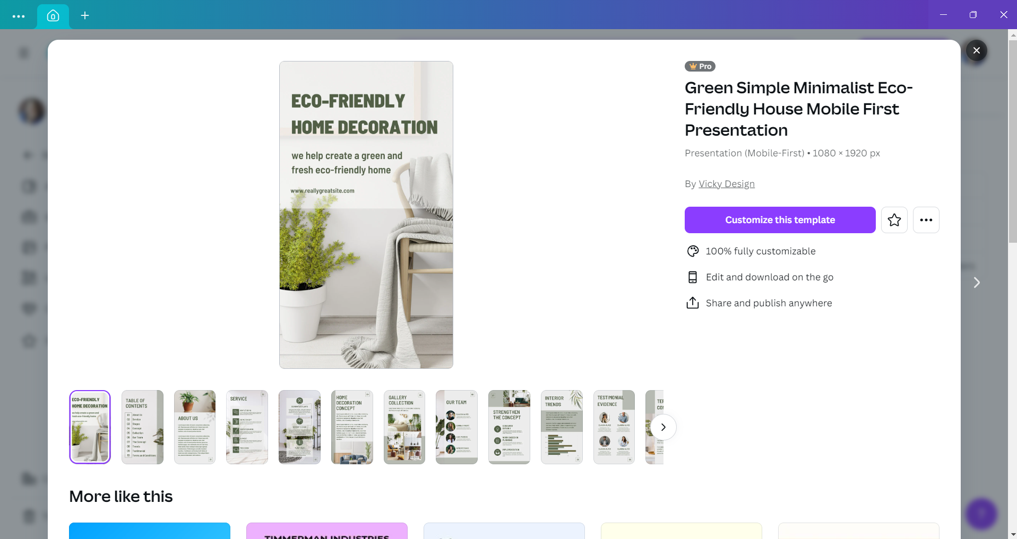

Detailed Procedure
1. Open the supplied template image and create a new Canva design that matches its aspect ratio.
2. Write a one-sentence brief naming audience, primary message, action and viewing context.
3. Create a named baseline page before editing.
4. Build Layout A with a dominant warning headline, one focal image area and a clear action zone.
5. Duplicate the page and create Layout B by changing only the grid and focal position.
6. Run a five-second hierarchy test with a partner and record the first three items noticed.
7. Select the stronger direction, state why it fits the brief and export a high-quality JPEG.

Evidence to Retain
Brief, two layout variants, five-second test note and final JPEG.

Acceptance Criteria
- The primary message is noticed first.
- Alignment and spacing follow a repeatable grid.
- The action is visible without competing elements.
- The final image exports at the intended size.
Lab folder: labs/lab-01-visual-brief-layout/

Lab 02 — Typography Hierarchy and Message Control
Scenario: Refine the heat-exhaustion communication so headline, symptoms and action read in the correct order.
Objective: Create a readable three-level type system and apply it to an awareness visual.
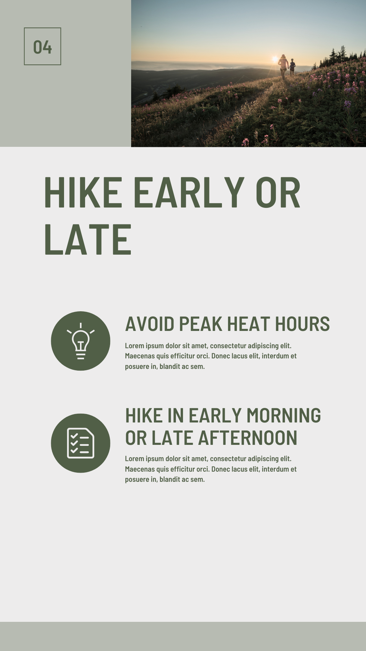

Detailed Procedure
1. Duplicate the approved Lab 1 design and rename the page Lab02-Typography.
2. Define display, heading and body type roles before choosing fonts.
3. Limit the system to two type families or one family with controlled weights.
4. Set headline scale and contrast so it wins the five-second test.
5. Adjust body size, line length, leading and alignment for the viewing context.
6. Check punctuation, capitalization and wording for consistency.
7. Test the design at 100%, thumbnail size and grayscale.
8. Export the final design as JPEG and capture a type-style reference page.

Evidence to Retain
Final JPEG plus a type-style reference showing font roles and settings.

Acceptance Criteria
- Three type levels are visibly distinct.
- Body copy remains readable at target size.
- No more than two font families are used.
- Typography supports rather than competes with the message.
Lab folder: labs/lab-02-typography-hierarchy/

Topic 2 — Colour and Form in Canva Design
Colour relationships · meaning · contrast · shapes · image treatment · context
Alignment: LO1

Key Concepts
Colour relationships: Analogous, complementary, split-complementary and triadic relationships create different levels of unity and contrast.
Colour meaning: Colour associations vary by culture, context and audience; test the intended interpretation.
Accessible contrast: Foreground and background must remain distinguishable at the actual viewing size and environment.
Form and shape: Geometric forms suggest order; organic forms suggest natural variation; both direct attention and tone.
Image treatment: Crop, scale, framing, overlays and colour adjustments must support rather than compete with the message.

Lab 03 — Colour and Form Mood Board
Scenario: Develop a natural, premium direction for the Two Trees olive-oil range.
Objective: Build a controlled mood board that communicates a brand personality through colour, shape and image treatment.


Detailed Procedure
1. Create a 1920×1080 mood-board page in Canva.
2. Write three brand attributes and one audience statement.
3. Sample or choose a five-colour palette with one dominant, two supporting, one accent and one neutral.
4. Add geometric and organic shapes that reinforce the selected attributes.
5. Place the supplied images without stretching and apply one consistent crop or colour treatment.
6. Add a concise annotation explaining each colour and form decision.
7. Review balance, contrast and negative space; remove any decorative element without a role.
8. Export the mood board as JPEG.

Evidence to Retain
One annotated mood-board JPEG and the five-colour palette.

Acceptance Criteria
- Every colour has a defined purpose.
- Images preserve aspect ratio and share a consistent treatment.
- Shape language matches the stated brand attributes.
- The board is coherent at thumbnail size.
Lab folder: labs/lab-03-colour-form-moodboard/

Lab 04 — Product Advertisement Design
Scenario: Create a premium advertisement for one Two Trees olive-oil variety.
Objective: Integrate product imagery, forms, typography and colour into a persuasive advertisement.
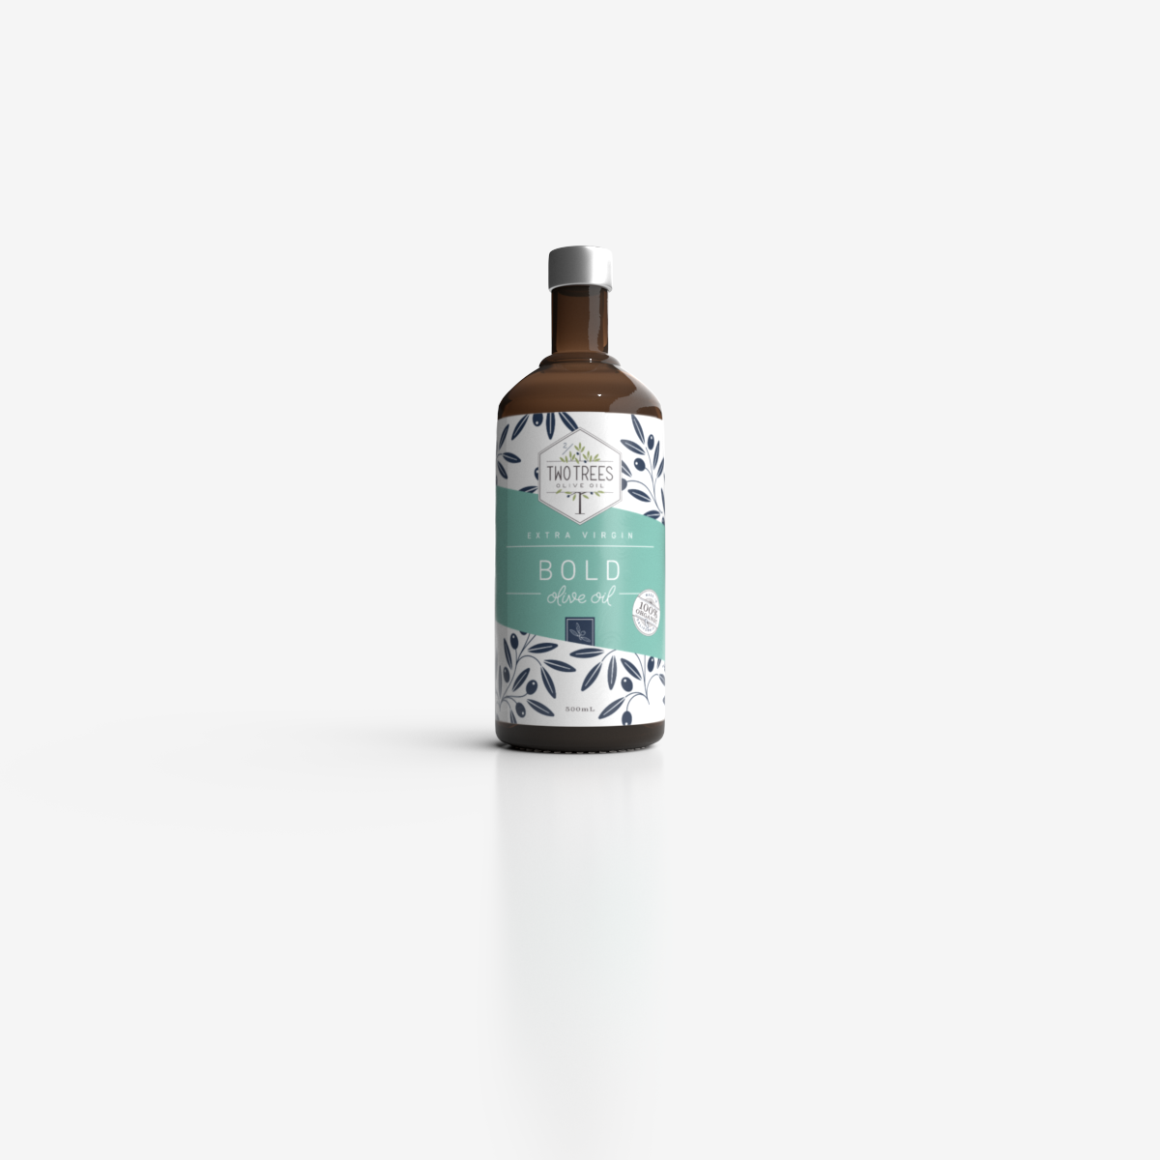

Detailed Procedure
1. Choose one product and write the audience, benefit and call-to-action.
2. Create a square social advertisement and establish margins and a grid.
3. Place the product as the focal element without stretching or obscuring the label.
4. Apply the Lab 3 palette with sufficient foreground/background contrast.
5. Use shapes to group supporting information and guide the eye toward the call-to-action.
6. Create one controlled variation using a different colour proportion or image crop.
7. Compare both versions against hierarchy, brand fit and readability.
8. Export the selected design as JPEG and retain the comparison image.

Evidence to Retain
Two design variants, comparison note and selected advertisement JPEG.

Acceptance Criteria
- The product remains the primary focal point.
- Colour and form reflect the selected brand direction.
- The call-to-action is visible and readable.
- The exported JPEG contains no unintended crop or distortion.
Lab folder: labs/lab-04-product-advertisement/

Topic 3 — Storyboarding and Flow Design in Canva
Narrative beats · sequence · task flow · annotation · transitions · shared intent
Alignment: LO2

Key Concepts
Storyboard purpose: A storyboard makes sequence, emphasis and production intent visible before expensive execution.
Narrative arc: Context, tension, resolution and call-to-action organise audience attention across scenes.
Task-flow logic: Start, action, decision, exception and finish nodes show how work or interaction progresses.
Shot and frame planning: Frame size, viewpoint, duration and transition describe what the audience should perceive.
Annotation and handoff: Notes clarify audio, motion, ownership, timing and acceptance criteria for collaborators.

Lab 05 — Storyboard Sequence
Scenario: Plan a six-frame heat-exhaustion awareness video from risk recognition to action.
Objective: Create an annotated storyboard that communicates a short visual narrative to collaborators.
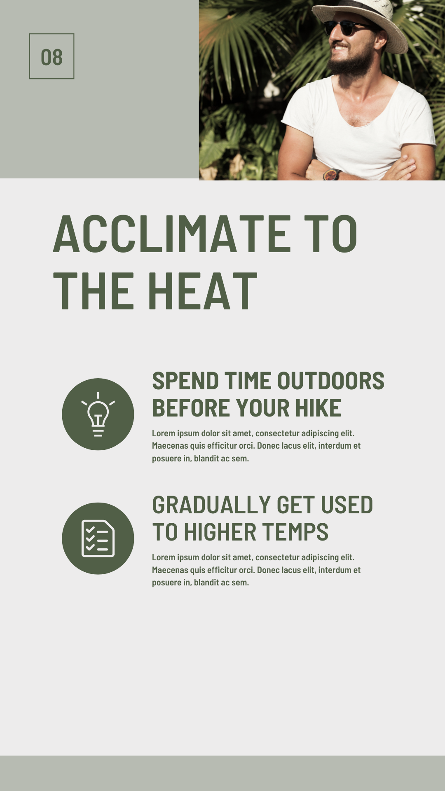

Detailed Procedure
1. Write the hook, risk, symptoms, response and call-to-action as a six-beat outline.
2. Create a six-frame storyboard grid with consistent numbering and annotation zones.
3. Assign one communication objective to each frame.
4. Place or crop the supplied image references to create visual continuity.
5. Add concise on-screen copy, duration and transition notes for each frame.
6. Check that the sequence includes context, tension, resolution and action.
7. Ask a partner to reorder the frame summaries without seeing the numbers; fix ambiguous transitions.
8. Export the annotated storyboard as a high-resolution JPEG.

Evidence to Retain
Six-frame annotated storyboard JPEG plus sequence-test note.

Acceptance Criteria
- Each frame has one clear purpose.
- The narrative progresses logically to the call-to-action.
- Annotations specify timing or transition intent.
- A collaborator can understand the sequence without verbal explanation.
Lab folder: labs/lab-05-storyboard-sequence/

Lab 06 — Task Flow Design
Scenario: Map how a marketing team requests, reviews, revises and approves a social graphic.
Objective: Model a visual-production workflow with clear actions, decisions and end states.
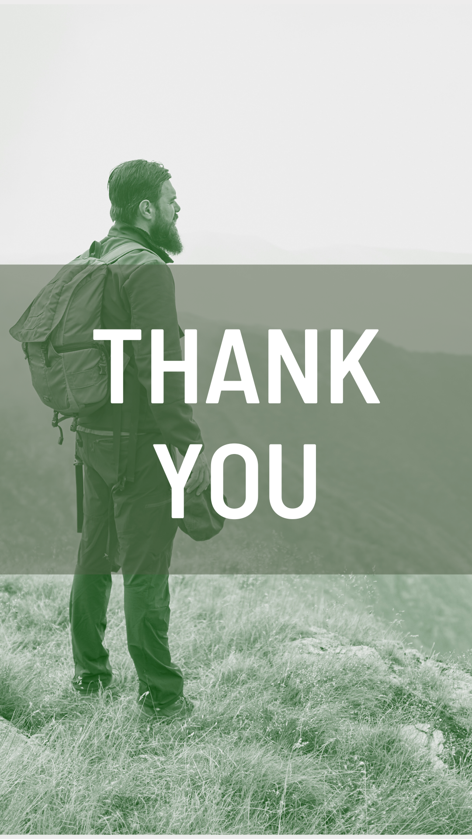

Detailed Procedure
1. List the actors, start trigger, major actions, review decision and two possible outcomes.
2. Create a landscape Canva Whiteboard or diagram page.
3. Use distinct shapes for start/end, action and decision nodes.
4. Connect the main path from request to approved export.
5. Label both outcomes from every decision and add one revision loop.
6. Assign an owner to each major action.
7. Trace every branch and correct dead ends or ambiguous connectors.
8. Export the completed flow as JPEG.

Evidence to Retain
One labelled task-flow JPEG with a verified revision loop.

Acceptance Criteria
- Every decision has labelled outcomes.
- Every branch reaches an end state.
- Connectors do not cross unnecessarily.
- Ownership is visible for each major action.
Lab folder: labs/lab-06-task-flow/

Topic 4 — Best Practices and Aesthetic Analysis in Canva
Design principles · usability · rubric-based review · diagnosis · evidence-led recommendations
Alignment: LO2

Key Concepts
Design-principle audit: Balance, contrast, hierarchy, alignment, proximity, repetition and negative space provide a shared review language.
Aesthetic and functional fit: Attractiveness is necessary but insufficient; the design must also be readable, usable and channel-appropriate.
Focal-point analysis: The first three seconds reveal whether scale, contrast and position produce the intended entry point.
Evidence-led critique: Describe the visible feature, explain its effect on the audience and recommend a specific change.
Usability and accessibility: Legibility, colour contrast, reading order and device context are measurable design requirements.

Lab 07 — Aesthetic and Functional Audit
Scenario: Review the Two Trees product advertisement as if preparing it for stakeholder approval.
Objective: Evaluate a design with a shared rubric and propose specific enhancements.
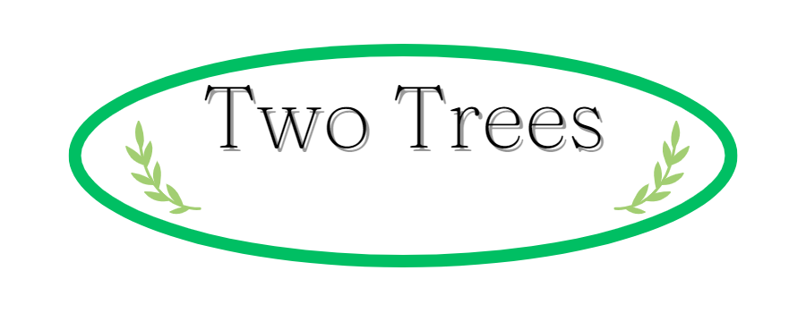

Detailed Procedure
1. Duplicate the Lab 4 design and label it Baseline.
2. Score hierarchy, balance, contrast, alignment, proximity, consistency and accessibility from 1 to 5.
3. For each score below 4, identify the visible feature and audience consequence.
4. Prioritise the top three issues by communication impact.
5. Write one specific revision for each priority issue.
6. Implement the highest-impact revision on a duplicated page.
7. Compare baseline and revised design at identical zoom and size.
8. Export a side-by-side review board as JPEG.

Evidence to Retain
Completed rubric and side-by-side baseline/revised JPEG.

Acceptance Criteria
- Every recommendation names a visible feature and expected effect.
- The highest-impact issue is addressed first.
- Comparison conditions are consistent.
- The revised version improves at least one rubric score with evidence.
Lab folder: labs/lab-07-aesthetic-functional-audit/

Topic 5 — Critical Review and Enhancement Strategies
Critique protocol · collaboration · version comparison · prioritisation · iteration
Alignment: LO3

Key Concepts
Critique the work: Separate the artefact from its creator and connect comments to the agreed brief.
Feedback quality: Specific observations and questions produce more useful revisions than taste-based approval or rejection.
Version comparison: A baseline and revised version make improvement visible and prevent untraceable change.
Prioritisation: Fix message and accessibility failures before cosmetic refinements.
Iteration loop: Observe, interpret, decide, revise and verify until the design meets its acceptance criteria.

Lab 08 — Peer Review and Iteration
Scenario: Review a Lakehouse menu or social tile and close accepted feedback actions.
Objective: Use structured comments and version comparison to improve a design collaboratively.
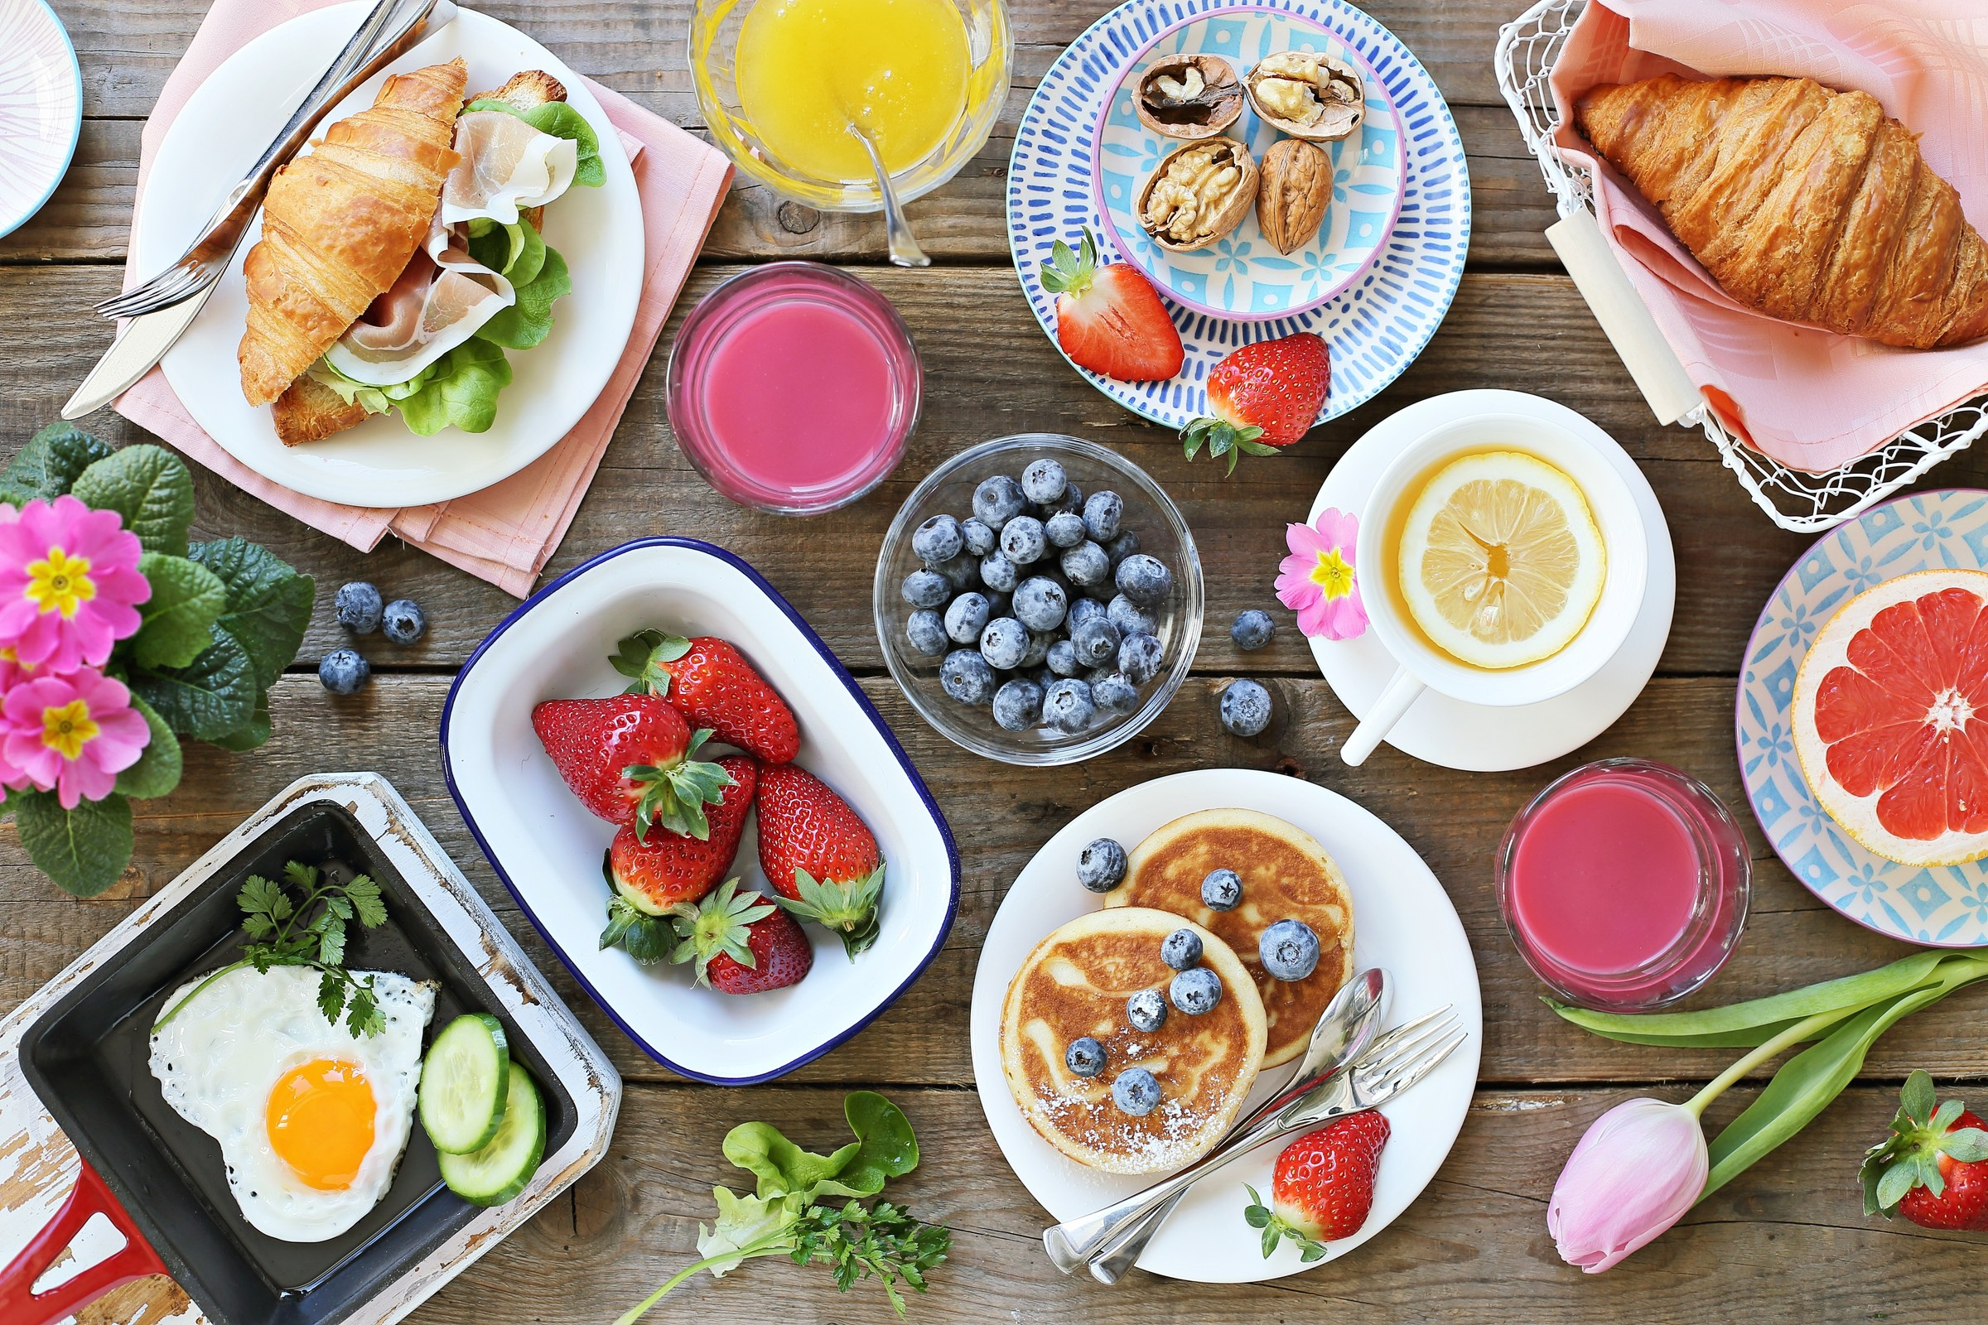

Detailed Procedure
1. Create a branded menu or social tile from the supplied food images and logo.
2. Name the first complete page v1-Baseline.
3. Share for comment or simulate a comment review with a partner.
4. Request feedback on hierarchy, colour, typography, imagery and brand consistency.
5. Classify each comment as accept, clarify or decline and record a reason.
6. Duplicate the baseline as v2-Revised and implement accepted changes.
7. Resolve or close each accepted comment only after verifying the result.
8. Export a before/after JPEG board and retain the decision log.

Evidence to Retain
Baseline, revised version, comment decision log and before/after JPEG.

Acceptance Criteria
- Feedback refers to explicit criteria.
- Every accepted comment is traceable to a revision.
- Baseline remains preserved.
- The revised design remains recognisably on-brand.
Lab folder: labs/lab-08-peer-review-iteration/

Topic 6 — Innovative Approaches to Design in Canva
Brand systems · reusable templates · collaboration · multi-format adaptation · responsible AI
Alignment: LO3

Key Concepts
Brand system: Reusable colour, type, image and layout rules make outputs recognisable across designers and channels.
Responsive adaptation: Recompose hierarchy for each format instead of merely resizing the same arrangement.
Reusable templates: Lock repeated structure while leaving clearly defined areas for safe content variation.
Collaborative governance: Roles, comments, approvals and version naming prevent conflicting edits and ambiguous ownership.
Responsible AI-assisted design: Generated material requires human review for accuracy, rights, bias, artefacts and brand fit.

Lab 09 — Multi-Format Campaign Adaptation
Scenario: Adapt a Lakehouse campaign into square post, vertical story and presentation slide formats.
Objective: Recompose one message across formats while preserving brand recognition and hierarchy.


Detailed Procedure
1. Define one campaign message and call-to-action.
2. Build the square post as the source composition.
3. Create vertical-story and 16:9 presentation variants.
4. Recompose rather than stretch: adjust crop, line breaks, spacing and focal position per format.
5. Keep palette, type roles, logo handling and image treatment consistent.
6. Check safe areas and reading order for each format.
7. Place all three variants on a review board and explain the controlled differences.
8. Export each format and the review board as JPEG.

Evidence to Retain
Three format JPEGs plus a comparison board.

Acceptance Criteria
- All formats preserve the primary message.
- No image or logo is stretched.
- Hierarchy is appropriate to each aspect ratio.
- The family is visually consistent across channels.
Lab folder: labs/lab-09-multi-format-campaign/

Lab 10 — Collaborative Brand Campaign Capstone
Scenario: Produce a launch mini-campaign for the Two Trees olive-oil range and prepare it for team handoff.
Objective: Integrate brief, mood board, advertisement, storyboard, critique and enhancement strategy into one coherent campaign.
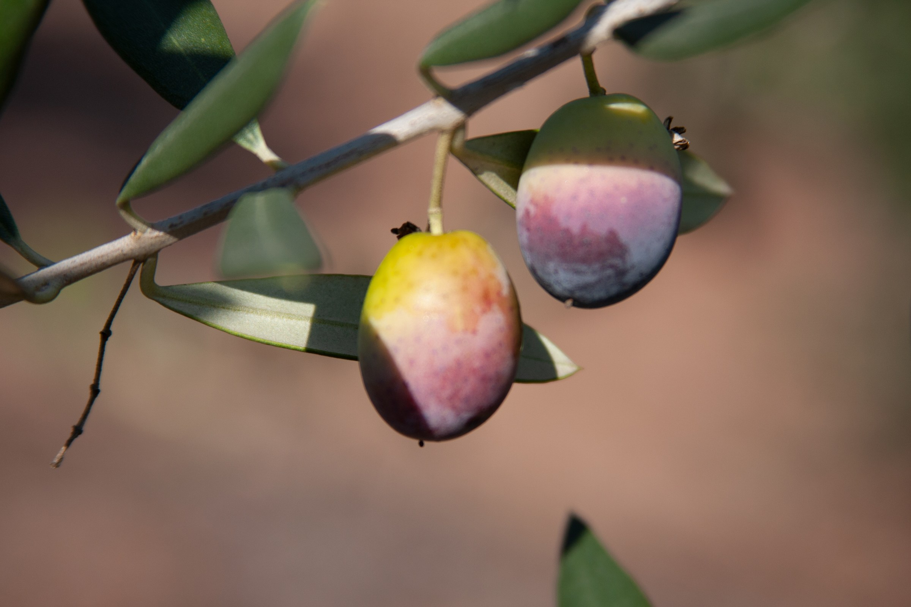

Detailed Procedure
1. Write the campaign brief with audience, message, formats, constraints and acceptance criteria.
2. Create a mood board and concise brand-rule page.
3. Produce one hero advertisement and one supporting social graphic.
4. Create a six-frame storyboard for a short launch sequence.
5. Organise pages with meaningful names and define owner/reviewer roles.
6. Conduct a structured peer critique using hierarchy, colour, typography and brand consistency criteria.
7. Record accepted feedback and revise at least one visual output.
8. Write an enhancement strategy naming changes, owners and expected effects.
9. Export the final campaign board and individual deliverables as high-quality JPEGs.
10. Verify every JPEG, then present the design rationale and revision evidence.

Evidence to Retain
Campaign brief, mood board, brand rules, two campaign visuals, storyboard, critique record, revised output, enhancement strategy and final JPEG package.

Acceptance Criteria
- The campaign is visually coherent across all outputs.
- Evidence for every lab stage is present and traceable.
- At least one peer-led improvement is visible.
- All JPEGs reopen at the intended dimensions without distortion.
Lab folder: labs/lab-10-brand-campaign-capstone/

Intellectual Property and Responsible AI
Use only assets you created or are permitted to use. Record source, owner, licence or consent, permitted modifications, commercial or redistribution scope and attribution. Review current Canva and AI-feature terms before commercial work, respect third-party rights in prompts and reference images, and retain provenance information where appropriate. This guide is educational information, not legal advice.

Source Register
Authority | Location
Legacy Canva exercise images | reference/Exercise Files/02 and reference/Exercise Files/03
Legacy Two Trees campaign images | reference/Two Trees Graphics
Official course page | https://www.tertiarycourses.com.sg/canva-design-masterclass.html
Canva Design School | https://www.canva.com/designschool/
Canva Help Centre | https://www.canva.com/help/

